Team Members
Anushka Karmakar GDF2 Rohan Carriappa GAF2
Aviroop Roy GDF2 Gagandeep Singh GAF2
Anirudh Dargar GDF2 Saurav Palliyil GAF2

Vision and Story
Game Vision
Mythic Fiction
Indian Futuristic
Neon Stylised Art
Universe
Hundreds or even centuries in the future, humans have reached a point, where they are making great strides in terms of advancements and technology. The humans have managed to do it all. Being able to completely change their body with cybernetic augmentations, solving terminal illness with just a capsule to be eaten with breakfast and making death a choice, not a requirement.
However, it got to a point where the Gods were just stories that were made fun of and the people believing in them were forced to change or live their lives ridiculed forever. Temples and Shrines felt the cruel assault of time, as it nurtured human innovation.
This all changed though, when the humans believing themselves to on par, if not more powerful, and in this intoxication of power, they tried to replicate what the Gods did billions of years ago…make life out of the ground that surrounds them. When the ground started to scream and wail as it gained humanity, the Gods appeared from their self – imposed exile in a flash of light, more disappointed than angry at their children.
Like children who had misbehaved, the Gods punished the humans by taking away their gadgets. In a blink of an eye, everything that the humans had built was destroyed and razed to the ground. The Gods realized they had to maintain a presence on the mortal realm, so that something like this could never be repeated.
The Gods built a floating city, whose foundations penetrated the Earth’s surface. Those who held onto their beliefs and faith in the Gods were allowed to be a part of this new city while those who had shunned and forgotten the Gods were forced to live on Earth. The city above blocked out the sun so the Earth was plunged in an eternal darkness. The humans with the vast knowledge they knew looked for ways to survive and overcome this making the world anew, one that was lit by the artificial warmth of the neon lights.
After the Gods were satisfied with this new World Order they returned back to their own domain, but they left behind one with the name of Yugrath. As time went by and the people that were banished on Earth forgot the golden warm rays of the Sun, Yugrath became more and more corrupt with power.
He started throwing people out of the God’s city he didn’t agree with. He ruled over Earth with an iron fist, branding and destroying people who fell even slightly out of line. He treated the world below him as a garbage dump, dropping useless and outdated tech. This eventually led to the rise of the Demons, a group of scavengers who would hunt through the garbage and make ends meet by selling and using whatever they could find. Cybernetic augmentations became a very common thing on the Earth with almost everyone having some form of another. Humans on Earth had no chance of getting to the God’s city and accepted their fate to die in the land of darkness, but all that changed when Savatri was born.
Lore
It has been several years since the Earth has plunged into an eternal darkness. Humans have forgotten what the sun felt like and were surrounded by the cold artificial light of neon. The Demon lord had gained power. Using the knowledge and his minions to make the mos]t of the tech that had trickled down below the Earth’s surface. The large vast army of his allowed for technology to be developed at an exponential rate and they had begun plans to take the God’s city and open it to everyone.
Savatri was born in this time of darkness blessed from the Gods with the purpose of defeating the Demon Lord, but as time went on it became obvious to the Gods that her prime years were slipping past her. Savita had a child and that is when the Gods realized that Savita was not going to follow the path to her destiny. The Gods came down from their realm to the mortal realm and appeared in front of Savita, on numerous occasions, trying to convince her to defeat the Demon Lord, but Savita declined them at every point, declaring her child to be the most important thing in her life. Savita had chosen a normal life, over one that promised riches, success, and fame. The first time she had used any of her powers of extreme strength was to protect her son. The Gods took notice of this and sent dangers to her son and every time she defeated them with ease using the powers that lay dormant within her. The Gods after all their through research, finally decided to come up with a plan to get Savita to fulfill her destiny in one way or another.
Player Character: Personality
Savita is a strong independent woman who always stayed true to her values and once her mind is made up there’s no chance of changing it. It was years of doing weird and odd jobs that caused her to become rough and rugged, which helped her navigate the way around tough situations. She will go through hell and back to protect and save the people she holds close to her heart as she was always taught that family came first.
Player Character: Description
Savita is a young normal Indian woman. She dresses in a saree, which have been wrapped around her legs to offer her greater mobility and agility, which is needed to survive on Earth. She has slightly defined arms and legs due to all the odd and strange jobs she had to do after her parents survived. Her face is soft and round to show the caring nature of a mother, but the eyes are slightly squinted to show how alert her mind was due to all the years of living on her own.
Player Character: History
Savita was born in the eternal darkness to her devotee parents. Her parents had prayed for years and years, ever since the Gods had come back and thought they could get into the City of the Gods just in time for their child. The Gods hadn’t granted them access, but they smiled upon her parents and gave them a child, whose destiny would change the entire dynamic of the world as they knew it. Her parents didn’t know about what fate their child held, but they were happy with raising her. They taught her the ways of the Gods, how to keep them happy, and how to make the most of her surroundings. They taught her that devotion to the Gods was important, but family was far more important. Her parents tragically died when the Demons from below the Earth’s surface came to the surface in another one of their raids. Her parents fought off the demons preventing them from taking Savita and making her into a demon as well, but they were killed off in a gruesome fashion by the Demon Lord. The Demon Lord looked at the child and turned away thinking her to be weak and useless.
Since that day Savita had learned to live alone. She took a variety of weird and strange jobs along the land to get by on a day to day basis. However, no matter the job or task that she had on hand she always found the time to pray and offer her thanks to God. The Gods in return kept her safe along her travels allowing her to get stronger and stronger till the fateful day, where she would defeat the Demon Lord. The God’s however didn’t plan on one thing though, Savita falling in love.
Savita married a man named Arjun and they had a beautiful boy together. This happy family was soon shattered when Arjun was killed when his cybernetic arm blew up in a freak accident. Savita was mad at first and hurt that the God’s had let something like this happen to her husband after all she had done for them. The rituals, the pujas, and the fasts were all for nothing as the love of her life was taken away from her. Her faith in the God’s disappeared and when the time came around that she was supposed to end the Demon Lord’s reign of terror, she had given birth to a child. She loved the child more than anything in the world. She always secured him from the dangers of the world and even when the God’s came down from their realm to ask her to fulfil her destiny, she responded with a no, as she wanted to protect her child.
Story
It was a normal day in the village and Savita had been taking care of her child, when a sudden rumbling reverberated the entire surface of the planet. The Demons had come up for another raid and had begun destroying the village and burning huts with people inside. The demons came to Savita’s house and Savita tried to stop them, but however she was over whelmed by the demons and quickly knocked out. When she came to it, she saw that her child was missing. Despite her being beaten and battered, she stumbled out of the hut to see her home completely destroyed and on fire. She knew however that she couldn’t break down just yet as her child was still missing. She stumbled to a shrine where she took rest, but when she stepped inside she felt all the numbness and pain in her body quickly rush out and she felt more agile and light on her feet. She had gained the ability to Double – Jump. She realized that this was the blessing of the Gods and decided to seek them out to find out why she had been given this power. She made her way through the jungle and got to a forgotten temple. She found a Chakra on the ground, but as soon as she picked it up it activated a Guardian. The Guardians were a strange mixture of stone and high tech, designed by the Gods to protect their Idols from the people who had tried to revolt against them and destroy them.
She uses the Chakra to defeat the Guardian causing one of the God’s to show up. The God recognizes her and explains to her that her child was destined to kill the Demon Lord who lay below the surface. The child being a vessel for the God’s power could only be killed on the rise of the Blood Moon and sacrificed on an altar.
Savita begs the God for help and the chance to try to get her child back and the God enthusiastically agrees and opens a portal for her to get under the surface of Earth in the realm of the Demon Lord. The God then says to Savita, that she must make her way through and find a Shrine and a Temple if she is to stand any chance against the Demon Lord and to prove her worth to the Gods themselves. Savita jumps into the Portal to the underworld, quickly defeating and killing demons that stand in her way powered by the might that is a mother’s fury. After getting to the hallway through the Demon Lords lair, she finally encounters the Shrine that the God had told her about. It is here where the God comes back and blesses her with the power of Wall Jumping to help her out in her journey, but when she gets out of the Shrine she finds the path to go down has been blocked by a seemingly immovable object that no matter what she can’t destroy. She tries and discovers a hidden path that seems be going upwards and uses her newly discovered ability to go up. She is blocked by creepy crawlers who scale the walls trying to get the jump on her and cause her to fall in her mission, but Savita preservers through it to get to a temple.
At the temple she fights another Guardian who drops a Mace. Using the Mace, she drops back down to the village where she sees that the villagers are crying over their dead, but before she can comfort them she looks up and sees that the Blood Moon has almost been filled and the time has drawn closer. Savita goes back under the surface and using the Mace gets further down till she reaches the Demon Lord. The Demon Lord has a Trishul which he uses to teleport around the player in a Boss Battle. When Savita defeats the Demon Lord, he tells her that someone else had told him to kill the child, but before she can get any more information out of him, he dies. Savita picks up the Trishul that is near the body and realizes that it’s a weapon of the Gods, but she puts that aside as she goes to the Alter Room to see her child impaled onto the altar. Savita lets out a cry of pain and goes back to the body. She picks up the Trishul again, but then an underground magma pocket explodes causing the whole Demon Liar to be filled with Magma. Savita makes her way through the secret passage in the Lair using the Trishul’s teleporting abilities and finds herself near the First Temple she encountered in the village. It is here when she pieces together that this was all the plan of the Gods to trick her into killing the Demon Lord.
Savita makes her way to the City of the God’s using the teleporting Trishul, but before she is allowed in she must find two keys to unlock the gate to the city. The keys are hidden in a large puzzle that Savita must solve using all of her abilities.
When she is granted access inside she meets Yugrath who tells her the plan of the Gods and how it was always her that was supposed to defeat the Demon Lord. The Gods used her love for her child to trick her into going down there, but now that she had killed him she would be allowed into the City. Savita channels all of her motherly rage as Yugrath uses all of his resources and technology on hand to stop her. Savita defeats him after a long battle. The story ends with Savita promising to get revenge on all the Gods who had wronged her.
Major Events
Initial Cut scene – Savita being beat up by a horde of demons and having her child taken away
First Game Screen – A village on fire as Savita limps through the Village. Wanton destruction showing that this isn’t the demons first time raiding this village.
Encountering the Shrine – A bright light encapsulates Savita as her health and strength comes back to her. She makes a comment of how she feels light on her feet. The game then explains how the player can now use Double Jump.
Path to Temple - Shows how deep in the jungle the forest is and how it’s been ignored and left to rot as vines and leaves cover the whole area as though nature were taking back its place.
Temple – Covered completely with Vines and Dead leaves with old graffiti saying “The Gods are a Lie”. Inside the temple there are stone carving showing the backstory of the village and the story of how everything had changed in a matter of moments. Savita meets with a God who tells her and the player about the Child’s destiny and the Blood Moon.
Portal/ Demon Lair – Showing garbage falling from the skies above showing that this place is a scrapyard. Enemies are in groups and hiding in the trash to give the illusion that they are looking through it. Enemies also have busted up and very old technology that is barely hanging on by a thread to show how depraved and how bad they have it down there.
Killing the Demon Lord – Finding the Trishul that belongs the Gods making Savita think about why it’s here. The Lord also mentions how he was told he had to do this to get to the City of the Gods, but dies before she can do anything. She finds her child dead, but then lava starts to rise. Using a secret path she gets to the Temple she encountered in the very beginning. It is here where it clicks that it was all the Gods planning and she had been tricked into doing this.
City of the God’s – Here is where the final confrontation takes place. This is where the player finds out what the Gods plan was and how it was her that was destined to defeat the Demon Lord. The gods had tricked her by using her child as bait.

Visual Direction and Experience
Art Direction Specifications
- We have decided on a style that all 3 artists feel comfortable with, drawn from several sources, including the personal styles of the 3 artists.
- The primary source of reference were the games: Hollow Knight and Ori and the Blind Forest. As well as the movies: Sanjay’s Super Team and The Secret of the Kells, for their relatively simpler character designs and art style, allowing for a faster animation process and for an attractive look n’ feel.
- Additionally, for both the environments as well as the character, we have taken some inspiration from Indian miniature paintings, especially for the simple structure and aesthetic quality of the backgrounds.
- Lastly, to bring out the futuristic aspect of our setting, we have sought to present a combination of organic and mechanical elements across both the environmental and character design, where they would suit the setting, with many bright neon and florescent lights and colours. For the temples which are neglected and abandoned in our setting, we have incorporated signs of the passage of time and the inhabitant’s attitude towards the structures, such as graffiti and decrepit architecture.

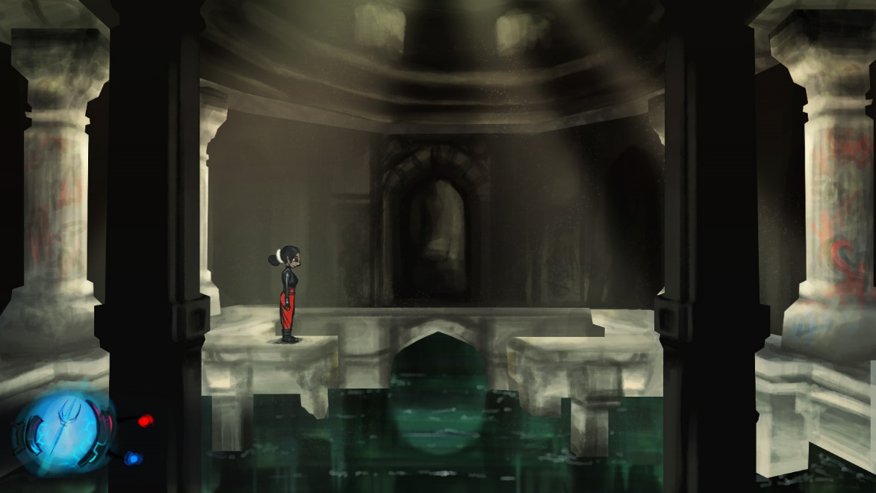
Look n’ Feel

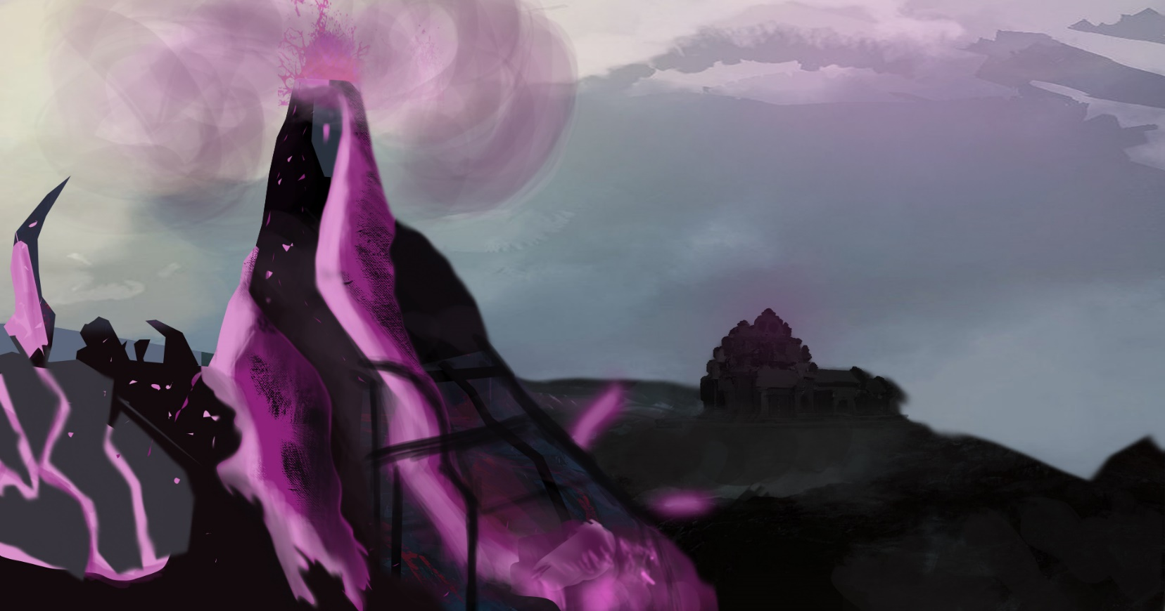
Concepts

Character Design
Explorations
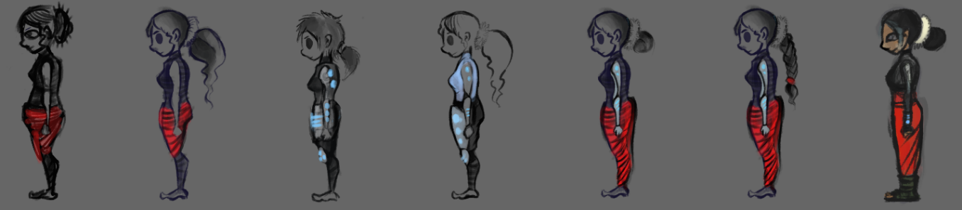
- Player Character

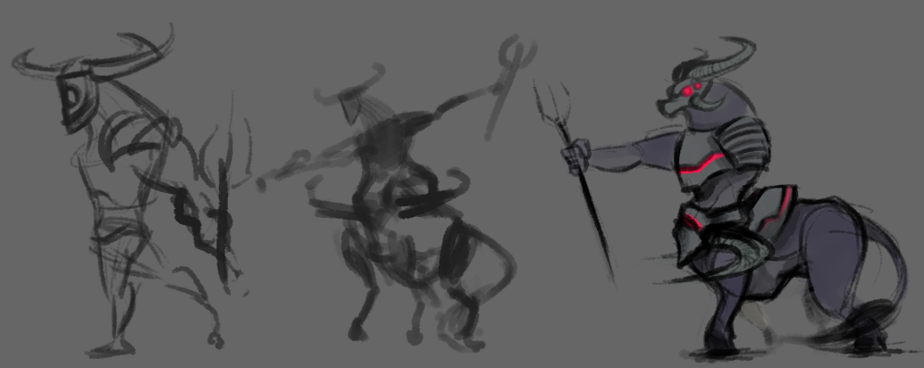
- Demon Boss

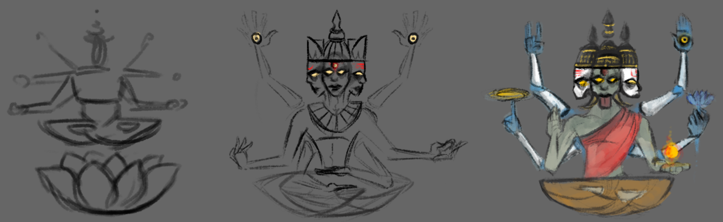
- God Boss

‘

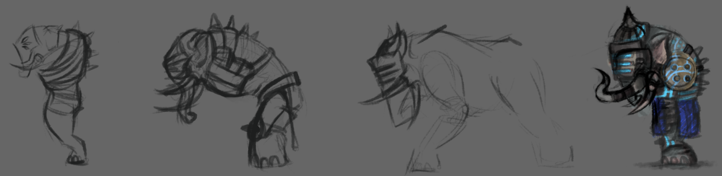
- Minions/ Guardians
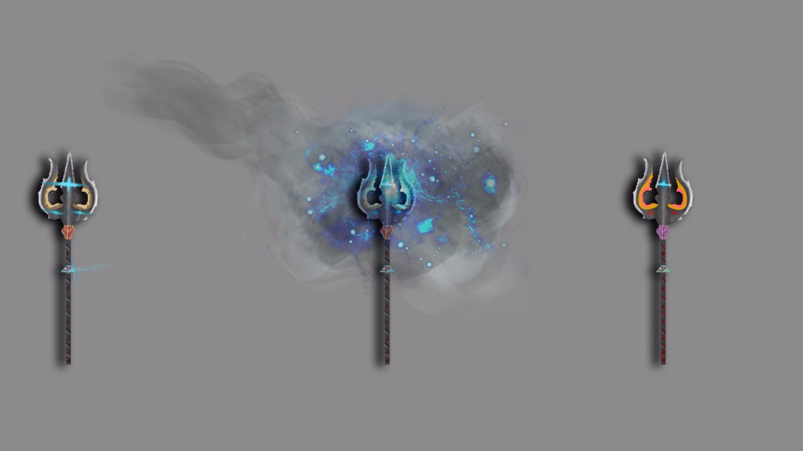
- Weapon

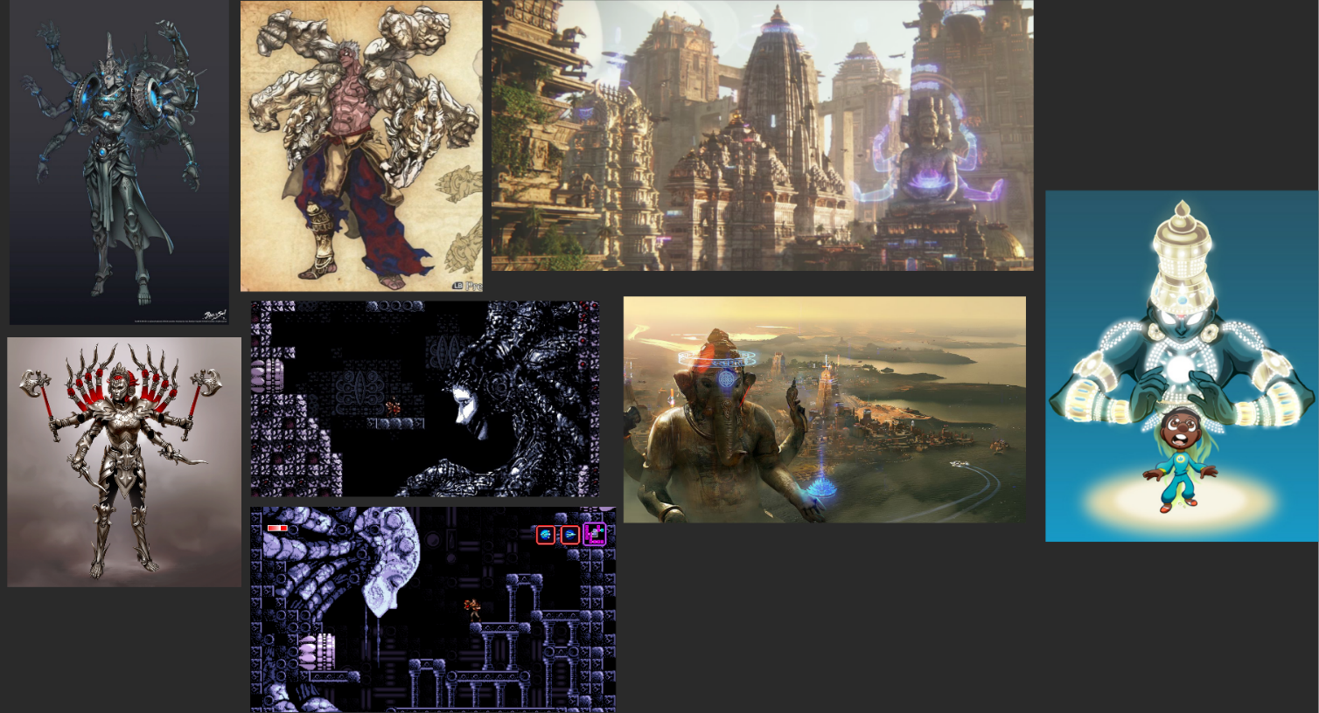
- Mood boards

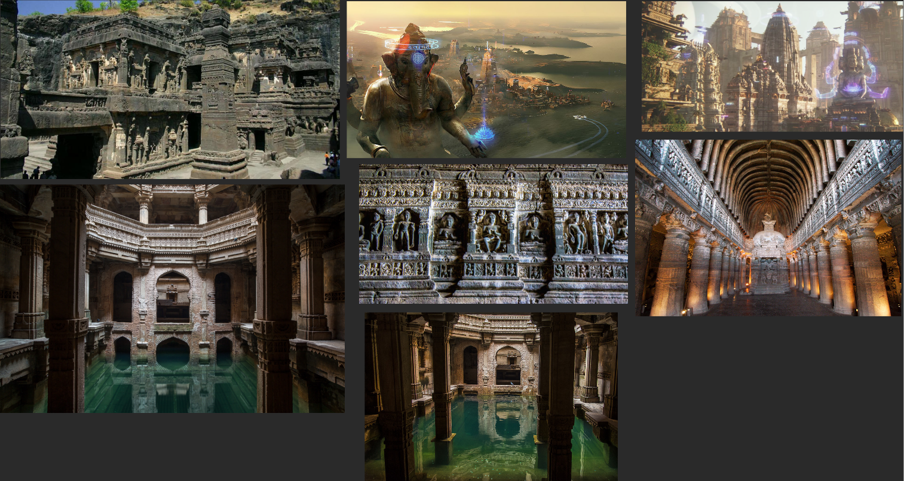

Animations for Player Character
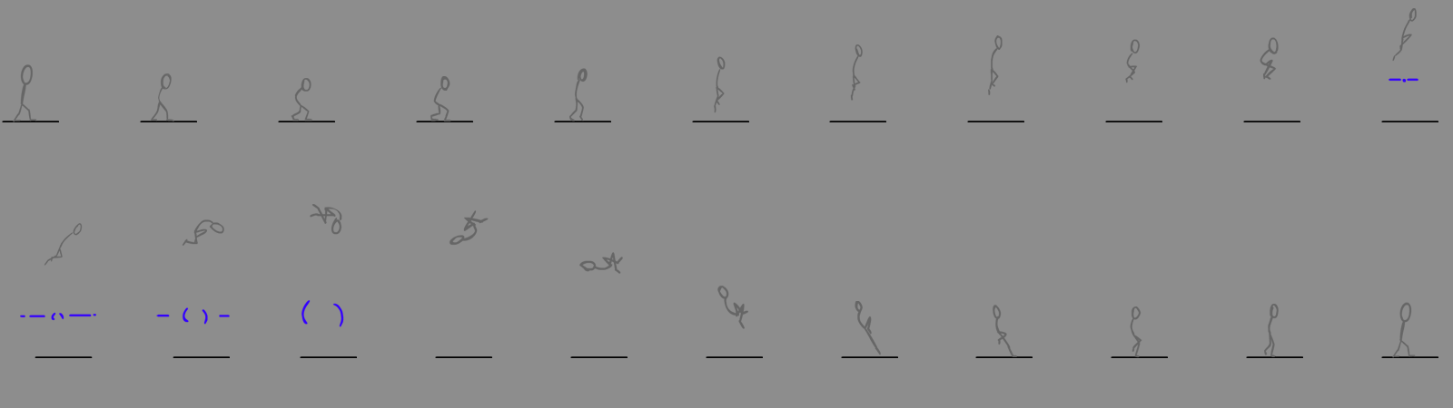
- Double Jump
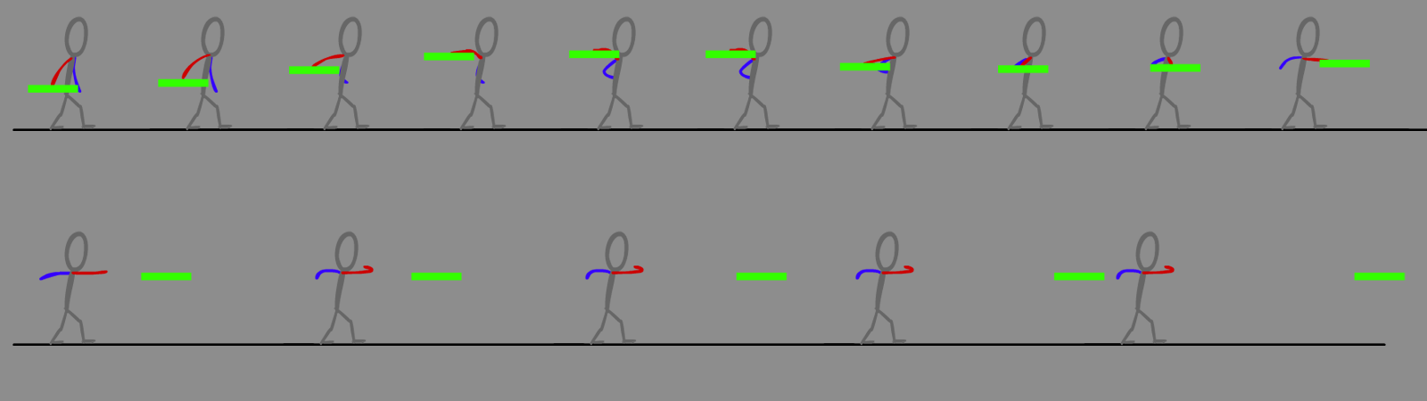
- Chakra

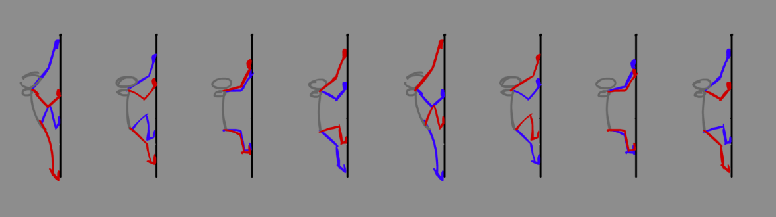
- Wall Climb
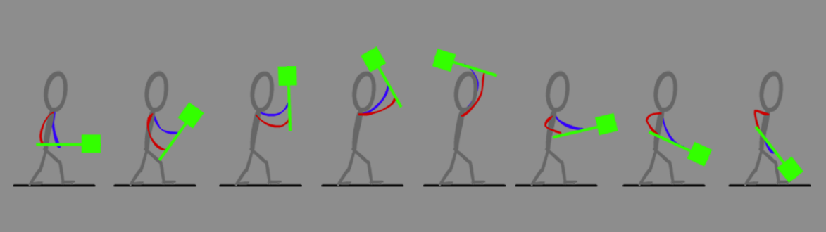
- Mace
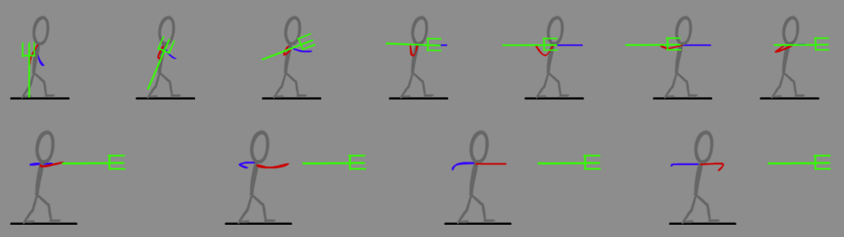
- Trishul

Game Design Specifications
Basic Mechanics:
The traversal of the map in game is determined by a set of very generic mechanics.
- Jump
The jump mechanic is one of the most basic traversal mechanics to have in game. It can be used to cover small chasms or jump over enemies to dodge them. Our jump has a subtle tweak to it, which adds to the Jump mechanic and makes it more intuitive. The basic jump has now been divided into two segments: -
Short Jump: -
When the player short presses the jump button, the character jumps a short distance in the y-axis.
Long Jump:
When the player long presses the jump button, the character jumps higher at almost a 1.4x the normal jump.
Note: both these jump types are compatible with the double jump mechanic. Therefore, helping the player reach variable distances according to the requirements of the level design.
- Double Jump
The double jump function allows the player to jump higher and cover longer distances. This ability works in synergy to the short jump and the long jump. Allowing the player to spam two consecutive long jumps or short jumps or a mixture of both depending on the requirement of the level.
- Wall Climb
The wall climb function works the same as the iconic wall jump ability on Metroid. With the addition of a few tweaks, the wall jump ability will look more realistic and believable. The character can use the ability with both short and long jumps.
While the character jumps from wall to wall trying to go higher and higher up a wall, there is a gain in momentum. If the player halts at a certain wall, the character will lose its momentum and start sliding down the wall. The player can continue the wall climb even after sliding down a bit.
- Movement
The most basic and the most important traversal ability falls under the movement mechanic. The character will have basic left/right maneuvrability. With a basic public variable to alter the speed of the character with relation to level design requirements.
The character will have a variable speed configuration depending upon the input of the player. If the player shifts the joystick slightly, the character will trot. If the character tilts the joystick all the way, the character will sprint.

Special Abilities (Weapons):
- Chakra
Combat:
- The Chakra is the first weapon the player gets in the game. The weapon has a very specific attack pattern. The player can spawn these at the press of the attack button when the chakra is selected from the weapon wheel. The chakra moves in the direction the player is aiming.
- The chakra gets destroyed after only one hit and has a 0.3 second cooldown.
- If the chakra does not come in contact with any enemy, the chakra gets destroyed after 3 seconds. It also gets destroyed when it comes in contact with the environment.
Traversal:
- The Chakra has its own unique uses for traversing the environment. After spawning the chakra, the player has to hold the attack button for one second to get it to its charged state.
- If the player long presses the Attack button, the chakra charges up to cut through environmental structures. In its charged state, the chakra can cut through vines to clear a path for the player. It can also be used to cut through spear heads. Therefore, making the path ahead accessible.
- Note: The chakra causes additional damage to enemies in its charged state.
GUI:
- Particle effect – Yellow
- Environmental elements which can interact with the Chakra will have a yellow glow.

- Mace
Combat:
- The Mace is the second weapon the player gets in the game. The Mace serves as a heavy weapon in the game. It has an AOE attack which causes heavy damage to enemy units.
- On the press of the attack button when this weapon is selected from the weapon wheel, the character slams the mace to the ground and an AOE wave damages all nearby enemy units.
- This weapon has a 3 second cooldown before the player can attack again.
- The enemies getting hit by the AOE wave are dealt with a knockback effect which pushes them away from the player.
- Stomp - The mace can also be used when the player is in the air, creating a stomp effect and making the character slam down to the ground at a greater speed. (The stomp ability only works when the player long presses the attack button while in the air). The stomp attack has a larger AOE and causes more damage to enemy units.
- Note: this ability works whenever you’re in the air, therefore allowing the player to use this ability with jump and double jump.
Traversal:
- The mace can be used for breaking through cracked walls.
- The mace can only break walls if the player uses the stomp ability. (explained under combat)
- The stomp effect stops as soon as the player breaks the wall. Therefore, allowing the player to use other abilities to get over obstacles (if any).
GUI:
- The mace will have a Red particle effect surrounding it.
- The environmental elements the mace can interact with will have a red glow to them.
- E.g. the walls which can be broken will have a reddish glow in their cracks signifying that they can be broken by the mace.

- Trishul
Combat:
- The Trishul is the last weapon you get in game. The Trishul uses its own unique set of skills. The player can spawn the Trishul once the attack button is pressed and the weapon is selected from the wheel. The Trishul fires in the direction the player is facing. The Trishul consists of a three-hit combo with a 1.5 second cooldown. The player can spam this weapon spawn thrice consecutively without any cooldown time after which the 1.5 second cooldown timer sets in.
- If the Trishul does not come into contact with an enemy or the map, it gets destroyed after 3 seconds.
- If the attack button is long pressed while wielding the Trishul, the character throws the weapon in a direction determined by the player. The Trishul disappears for 1 second and then reappears in its updated position, to which the character is then teleported.
- This attribute of the Trishul can be used during combat to get behind shielded enemies and strike them down from behind.
- Note: the teleport range will be decided according to the level design.
Traversal:
- The Trishul has to be in its charged state to be used as a teleporting device.
- The player has to hold the attack button for 1 second to get the Trishul charged.
- Once charged, the Trishul can be used to go through tight spaces and cover longer gaps in the level. It can also be used for reaching higher ground.
- The teleport ability can be used in cohesion with the double jump and wall climb mechanics. The addition of this mechanic helps the game test the player’s skills and make traversal a little more challenging.
GUI:
- The Trishul will have a Blue particle effect surrounding it.
- The areas which are hidden and can only be accessed by teleporting through tight spaces will be illuminated by a slight blue glow.
- Note: the three-hit combo remains the same even when the player is in the air allowing more dynamic combat-traversal sequences.
Unusual Mechanics:
- Weapon Wheel
The weapon wheel works as a central hub for all the weapons provided to the player. The weapon wheel can be controlled using the directional buttons. One directional button is assigned to each weapon making the switching of weapons more easy and intuitive. This allows the player to switch weapons quickly during combat/traversal and make the gameplay more dynamic.

Extras:
- Diya
The game will have Diya’s spread throughout the map acting as save points. These save points will revitalize the health of the character to full.
- Shrines
The different abilities the player gets will be given through the shrines in the map.
- Temples
The temples in the game provide the player with the different weapons.
Enemies:
Note: the names and the look and feel of the enemies are yet to be decided.
- Static enemies
- Spikes/Thorns – basic enemies which damage the player when touched. These enemies can be avoided by using Jump/Double Jump/ Teleport.
- Lava Vents – basic enemy type which gives out a burst of lava at regular intervals. This lava when touched, damages the player. These enemies can be avoided by using Jump/Double Jump/ Teleport abilities.

- Moving enemies
- Charging Enemies – these enemies charge at you when you enter a certain range. They deal damage when they come in contact with the character. They can also be used to break certain walls.
- Spawning enemies – this enemy spawn’s multiple smaller minions around it. The minions can deal melee damage while the larger enemy can only spawn minions. This enemy can muster a total of three waves of minions after which the enemy dies itself. The enemy dies only if all it’s minions are dead and/or it loses all it’s health.
- Normal Shield Enemy – this enemy wields a shield which it uses to block your attacks and get closer to deal melee damage. This enemy can be attacked using the Mace weapon. The shield cannot protect against AOE damage.
- Holographic shield enemy – similar to the normal shielded enemies, this enemy wields a holographic shield which cannot be penetrated by any attack. These enemies can be bypassed using the Trishul’s teleport ability to get behind them and strike them from behind.
- Flying bird enemy – this bird will swoop down to the characters last location and cause damage on impact.
- Shooting enemy - this enemy will be of two types. One of which will shoot directly at the character and one of which will shoot in multiple directions at random but in the direction of the player.
Obstacles:
- Doors – these doors will only open if the player defeats a certain enemy/ collects the door keys/ completes an objective.
- Cracked Walls – these walls will only break if a charging enemy breaks through it or if the player uses the Mace’s stomp ability.
- Vines – these vines can only be cut using the chakra’s charged ability. Therefore, clearing up a path and opening up newer areas.
- Spear Heads – the spears are responsible for blocking certain paths which cannot be covered using jump/double jump/ teleport ability. The spear heads can be cut off using the charged Chakra, converting the spear heads into log heads which can be hopped upon to traverse the level.
- Tight Spaces – the areas through which the character cannot fit can be bypassed using the Trishul’s teleport ability. Giving the player access to more areas.
Controls:
Playstation:
Button | Effect
- X | Jump
- X+X (consecutively) | Double Jump
- X (On wall) | Wall Jump
- □ | Attack
- □ (Long press) | Special attack
- Analog Directional Buttons | Weapon wheel

Xbox:
Button | Effect
- A | Jump
- A+A (consecutively) | Double Jump
- A (On wall) | Wall Jump
- X | Attack
- X (Long press) | Special attack
- Analog Directional Buttons | Weapon wheel

Game Features:
- Chakra – the chakra acts as an important aspect of the level design of the game as it gains the player access to different areas. This is the first weapon the player gets in the game. As the level proceeds, this weapon is responsible for pushing the story forward. The chakra is received on the surface and the player gets access to deeper layers of the world. This is a low damage weapon light weight weapon which the player can use to keep spamming enemies with attacks.
- Mace – the mace acts as an important traversal mechanic which helps the player proceed to the different areas situated below the surface. This is a heavy weight weapon which can cause heavy damage to enemy units in an AOE. This weapon has a considerable cool down timer which is balanced by the knockback effect it gives the enemies.
- Trishul – the Trishul is the only way the player can access the final area of the game. The Trishul opens up a lot of different level design probabilities. This is a medium damage weapon which the player can only spam thrice before it having to cool down for 1.5 seconds. This weapons teleport ability has both combat and traversal uses. The player can use this to teleport behind enemy defenses and take them down. For traversal, the player can use this to cover longer distances and go through tight spaces.
Beneficial Role in Game Vision:
- Chakra – the chakra acts as an introductory weapon for the game. An iconic weapon of the Indian myth, it immediately places the player in the setting of the game.
- Mace - According to Indian myth, demons lived in Paatal or hell. Hanuman, one of the most iconic gods of the Indian myth used a Gada or a Mace to vanquish the demons of Lanka. Hence, it made sense if the player would use a mace to go lower and lower to gain access to the demon realm.
- Trishul – the god in the story of our game is destined to die at the hands of The Demon Lord hence he plots this plan to kill the child of the one destined to kill the demon. Once the demon was killed, the mother of the murdered child confronts the god with a weapon of the demon lord, the Trishul. Therefore, the god met his doom at the hands of the Mother wielding the Trishul of the demon.

Visual Walkthrough
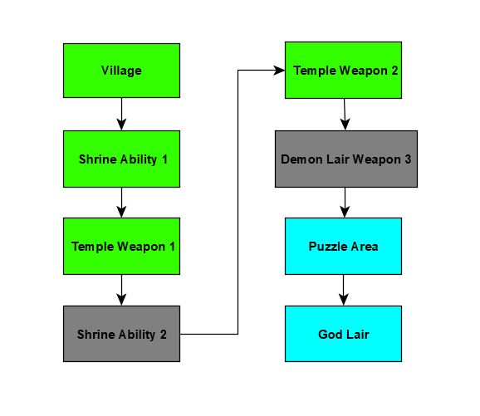

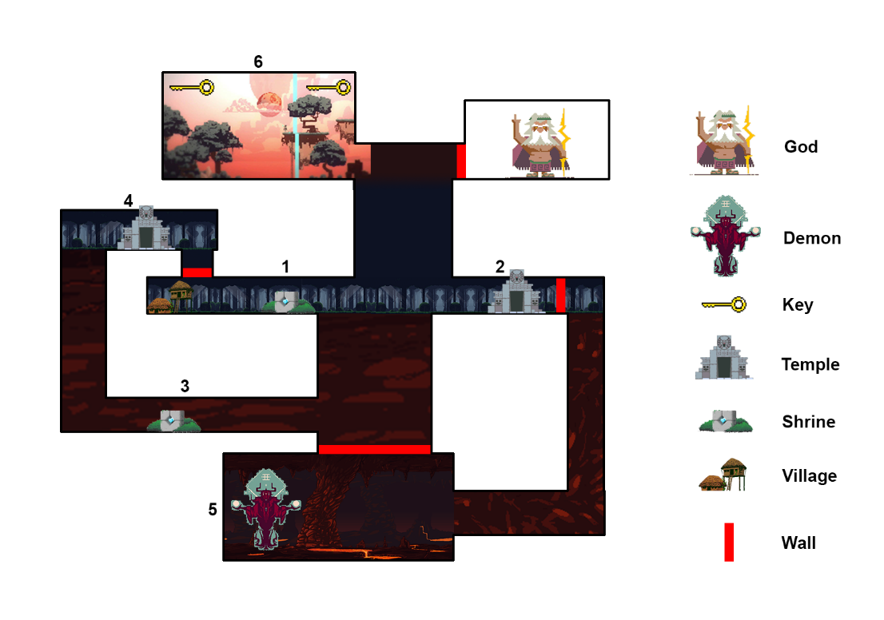
- The player starts from Village in game after the cut scene is shown that makes the player character slow down her movements until she reaches a shrine. This area has dark and neon elements showing the player situation of the game through environmental storytelling.
- The player then proceeds to the first Shrine marked on the map as 1. This is where the player learns that shrines regenerate health and the use of Diya’s as save points. This is also where the player gets their first ability, the Double Jump Ability.
- The player proceeds from here to go to the Temple. This is where the first temple is introduced marked 2. The player receives their first weapon i.e. the Chakra and encounters its first enemy, the Guardian. The player learns how to use the weapon and then proceeds to get an objective of killing the Demon residing at the demon lair beneath.
- The player then moves down from here but finds out that the area is blocked. After some exploration the player finds a shrine. This is the second shrine in the game marked 3 which gives the Wall Jump Ability. The player realises that he/she will require something to break through the ground to enter the demon realm.
- Then the player uses to its ability and climbs higher and reaches the second temple marked 4. This is where the player gets the second weapon, the Mace to go deeper into the demon realm. The player can now access the breakable the ground beneath which drops the player down to the village again.
- The player reaches the demon lair through breaking the previously unbreakable path. This area has mainly fast-paced platforming gameplay with variant enemies. The player then reaches the Demon and fights him until defeated. The player then gets the third weapon, the Trishul marked 5.
- The player then gets another objective through the cut scene. This triggers lava rising up in the level with requires fast-pace platforming and timing to reach to the same first temple.
- The player then realises the connection of the demon and the god and heads up to the god lair using her combination of abilities and weapons.
- After reaching up, the player needs to find 2 keys that will open the path to the god realm marked 6.
- The player then solves the puzzle in area and finds the 2 keys with variant enemies to kills and puzzle to solve.
- Now with all the abilities in the inventory, the player can use them to reach the realm of the Gods, defeat the God Boss and avenge the death of the child.

